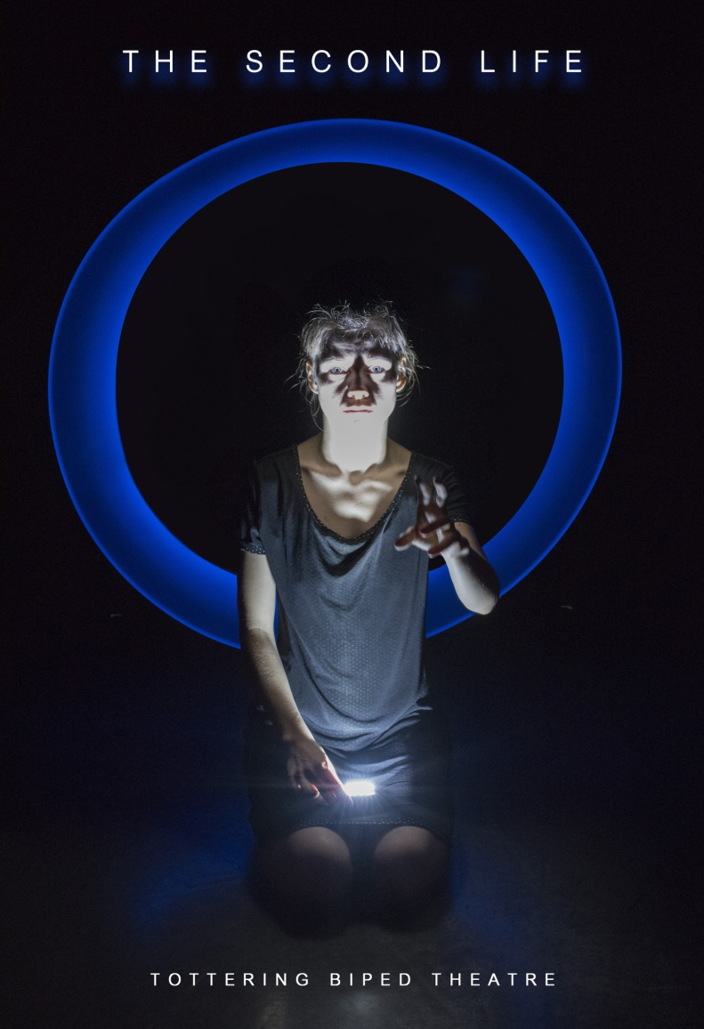

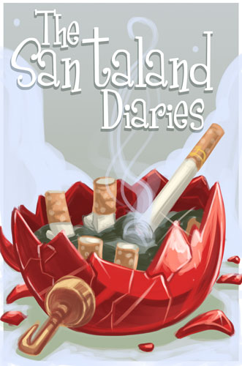

THE SECOND LIFE

Created by: Tottering Biped Theatre workshop team/Trevor Copp

Developed in part through pat the dog playwright centre

Actors: Jenna Harris, Julia Krauss, Zach Parsons

Playwright/Director/Lighting: Trevor Copp

Stage Manager: Rose Hopkins

Set Design/Build: Jacqueline Costa

Music: Sigur Ros
Length: 1 hour 5 minutes (No Intermission)

WARNING: SHOW CONTAINS STROBE LIKE EFFECTS

TOTTERING BIPED THEATRE

Our mandate is to promote conscious evolution through Theatre, emphasizing themes of social justice. TBT was founded in 2008, is a member of the Professional Association of Canadian Theatres and is a registered charity. www.totteringbiped.ca.
Our Theatre emphases highly physical work tied to social issues. Our works have featured issues of poverty, Israeli-Palestinian relations, same sex marriage, violence against women, and mental health. Our productions have toured to Professional Theatres and festivals Nationally and Internationally, and have been featured in over 15 different publications including the Canadian Theatre Review.

THE SECOND LIFE

From the company that presented First Dance and The Last 15 Seconds – Tottering Biped Theatre takes you back to the early days of the internet, exploring the increasingly fluid relationship between the real, the digital and the spiritual. The online virtual world of Second Life stretches thousands of kilometers and millions of visitors. While searching for her lost sister, Jessica struggles to find out what – and who – are real. Life and its double are at stake in this multi-media exploration of loss in the digital age. The Second Life was devised by the company through workshops with light, movement, and text over a four-year period.
Talk backs will be held after each of the performances with various members of the company.
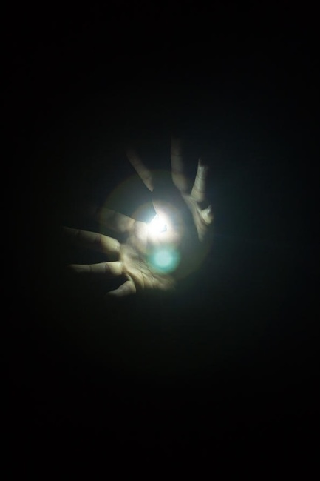
“If you are interested in the new face of theater Second Life is a must see drama that explores a dark and disturbing world of cyberspace. A tense provocative evening of theatre, Trevor Copp’s drama is a lethal, riveting look at a world rocking on the edge of frightening discoveries that will threaten your sleep at night.”

-Gary Smith, The Hamilton Spectator

“an evening of ethereal, otherworldly provocation …I felt myself somehow suspended in time and space … [Copp’s] endeavours promise to be the wave of theatre future.”

-Tamara Kamermans, View Magazine

CAST & CREATIVE TEAM
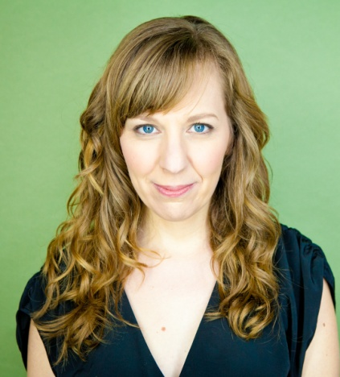
Jenna Harris is a graduate of the American Academy of Dramatic Arts theatre conservatory program in New York City, and is an actor, writer/creator, arts educator and dancer. She is also the Artistic Director of Discord and Din Theatre, and a founding member of [elephants] collective. As an actor, Jenna has worked in both the United States and Canada and most recently appeared in This is Where We Live at the SummerWorks Theatre Festival. As a writer, Jenna has written everything from radio shows to animated shorts, webseries to feature films, site-specific work to full-length plays, and is the Editor-in-Chief of City Voices: A Book of Monologues by Toronto Artists. Jenna's play Mine was part of the 2015 Next Stage Theatre Festival, and she is currently a member of the 2015-16 Tarragon Playwright’s Unit and Studio 180 Theatre’s inaugural IN DEVELOPMENT program. Jenna’s arts education and teaching background includes teaching dance at Alvin Ailey American Dance Theater, Ballet Tech and the 92nd Street Y in New York, and here in Toronto, at numerous theatre schools and youth collectives.
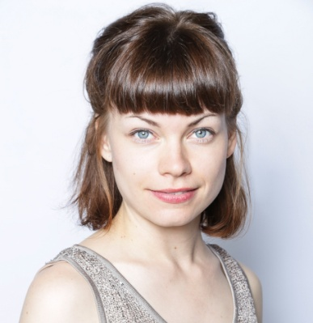
Julia Krauss is an actor and theatre director based out of Toronto, Ontario. Julia’s acting experience includes working with physical & devised theatres like The MT Space in Kitchener-Waterloo (Ontario); Ghost River Theatre in Calgary (Alberta), and Push Theatre in Rochester (New York). For the last two years, Julia worked with the Southern Ontario Youth Theatre Festival to showcase physical & devised theatre from young, emerging artists. Past credits as an actor include the role of Lisa in the MT Space’s Theatre for Social Change piece Just Faith?, Jennifer in Occupy Spring (MT Space); Tess in Quantum Entanglement (Flush Ink Productions); Mary in The Twilight Zone (Ghost River Theatre); and Laura in Fear Project (Studio Players/ MT Space). Earlier this year, Julia assistant directed Parents Night alongside George F. Walker and Wes Berger.

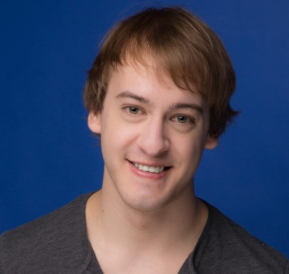
Zach Parsons is an alumni of the Theatre program at the University of Waterloo. Some highlights at UW include such roles as Bottom in A Midsummer Night's Dream, Antipholus of Syracuse in The Comedy of Errors, and many others. Elsewhere, his recent credits include Charlie in the world premiere of On The Inside (Lost&Found Theatre), Elliott in the Toronto Fringe show Cut-Throat: The Isolation of Ambition (PACE Theatre), as well as some staged readings here and there, and lead roles in a few independent feature films. He's returning to Tottering Biped's The Second Life as Nathan, and is thrilled to again be working with such a fantastic team to bring the show to life.

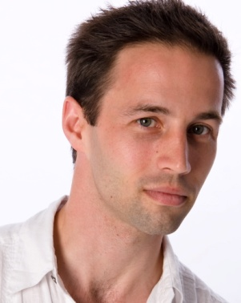
Trevor Copp founded Burlington’s Tottering Biped Theatre (TBT) in 2008. He completed Theatre Studies at Waterloo, a MA at Guelph, and Mime at the Marcel Marceau School in Paris. Trevor co-created TBT’s First Dance and MT Space’s The Last 15 Seconds and Body 13, shows which he performed at the Theatre Passe Muraille, Grand Theatre and Theatre Aquarius seasons, the IMPACT ’09/’11, Magnetic North, and Canoe Festivals; National tours, and a tour of the Middle East and Albania. As an actor, he also performed in TBT’s Thom Pain, Home Free, The Ends of the Earth; Oakville Festival of the Classics’ Pericles; Theatre & Company’s Beauty and the Beast, Metamorphosis, Ten Times Two and Barefoot in the Park; and Motus O Dance Theatre’s The Shunning. Trevor is also a regional American Style Latin Champion, Mime, and Contact Improvisation practitioner.

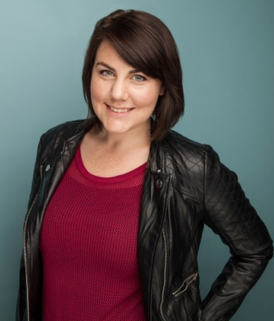
Rose Hopkins is a Hamilton-based actor, playwright, and producer. She graduated from UWindsor’s BFA Acting Program, and since then has been working on and offstage. Rose has been a participant in Toronto Fringe's 'TENT' program; Hamilton Fringe's 'ALERT' program; Directing and Marketing Intern with Theatre of the Black Butterfly in Montreal; and is currently an artist in STAF’s ‘Artist Producer Program.’ She is the founder of Mooncalf Theatre, a company dedicated to supporting emerging artists in creating and producing socially-conscious work in sustainable ways. She wrote, produced, and performed The Rabbit Done Died, which won "Best of Galleries" at the 2015 Hamilton Fringe Festival and was called an "Artist to Watch" by Raise The Hammer. Rose’s next project is a site-specific piece that will be performed at the 2015 Frost Bites Festival, Hamilton’s first site-specific winter festival, in February.

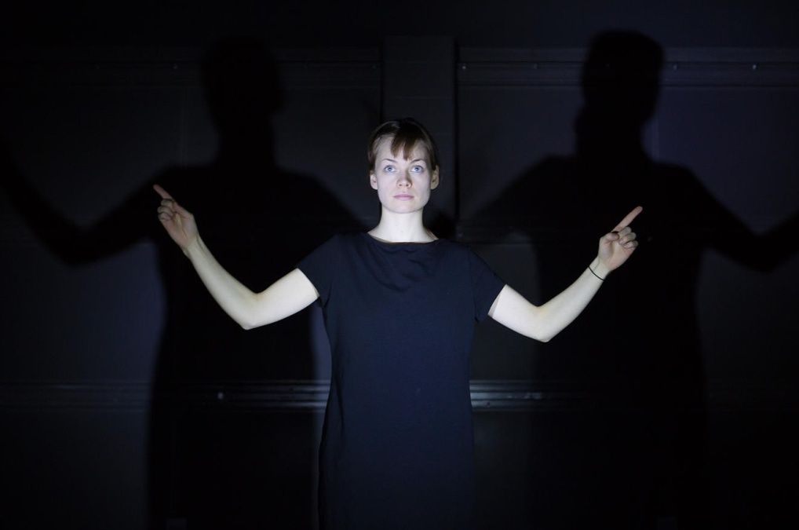

THANK YOU

Terry & Sandy Montgomery, DEC Express

Burlington Performing Arts Centre

Theatre Departments at U Guelph and U Brock

Burlington Student Theatre

Theatre Aquarius

Peter Krauss

Jessica Allen

Special thanks to the workshop participants over the past 3 years whose contributions shaped the play enormously: Lisa O’Connell, Olga Barrios, Gabriella Colavecchio, Andrew Cromwell, Vicky Sullivan, Kit Simmons, Henny Hamilton, Sierra Spence, Rob Ring, Laine Newman, Bernie Rhode, Cody Burns and UBrock’s Mirror Theatre.

This project was made possible through funding from the Burlington Community Foundation, The Ontario Arts Council, and the Canada Council of the Arts.
